Hypothesis for Project:
We think that there will be different levels of acid in each substance.
Theories of acid levels (highest to lowest)
- Pineapple
- Coke
- Bath bomb
- Banana
- Dirt
Materials Needed:
- Bromothymol Blue
- Dirt
- Banana
- Coca Cola
- Pineapple
- Bath bomb
- Beaker
- Water
Actual Ph levels:
-Coke
-Pineapple
-Banana
-Dirt
-Bath Bomb
Cabbage Juice Explanation:
When the cabbage juice reacted with the base (bath bomb), OH particles attached onto the chemicals in the cabbage juice, which caused it to turn a green colour, indicating that it was a base.
When the cabbage juice reacted to any of the acids (pineapple, banana, coke), it gave hydrogen to the anthocyanin, which caused it to turn more and more red depending on how low the pH was.
The anthocyanin in the cabbage juice is what reacts with the H+ and the OH in different products, which in turn causes them to change colour depended on how high or low the pH in each product is. If the pH is below 7, it turns red or pink. If the pH is exactly 7, it will not react, because it’s neutral. If the pH is above 7, it will turn green or yellow.
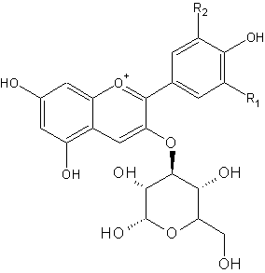
This is the anthocyanin without having reacted with anything
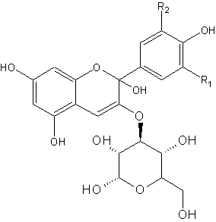
This is the anthocyanin after having reacted with a base. As you can see, an OH particle has attached on, causing it to turn green.

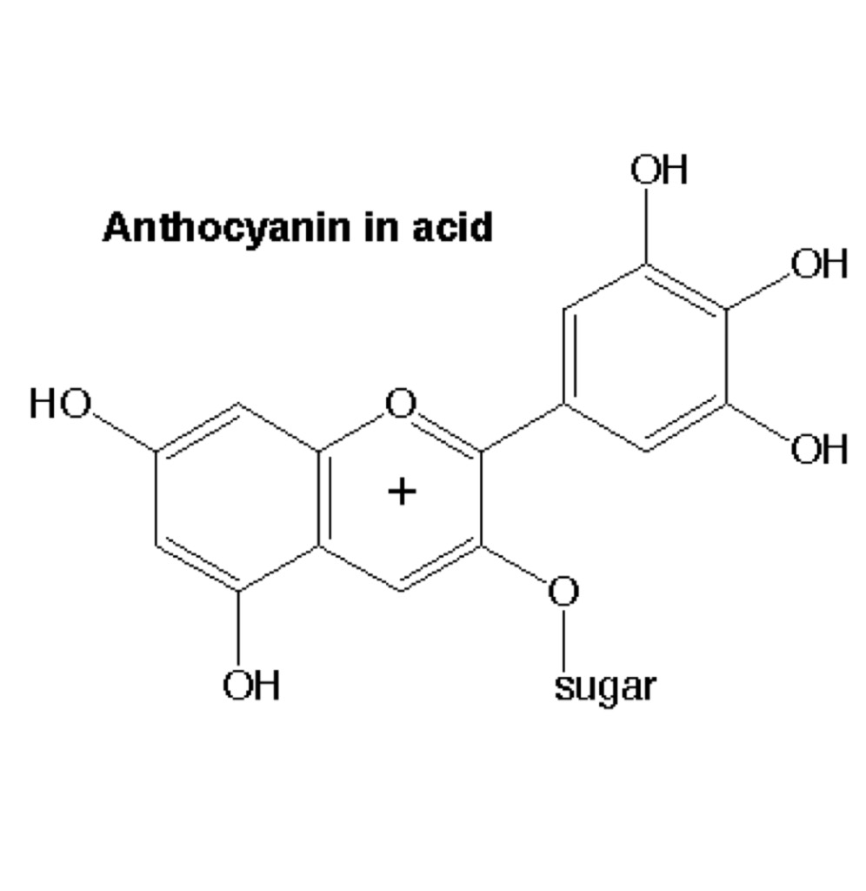
This is the anthocyanin with acid. It have more hydrogens, causing it to turn pink.
Chemical formulas for acids:
Pineapple: Ethyl butyrate
C6H12O2
Cola: Coca Cola
C30H32N8O10

Banana: Isoamyl acetate
C7H14O2

Chemical formula for base:

Bath bomb: Sodium bicarbonate
NaHCO3
Chemical formula for neutral:

Dirt:
There’s nothing in it to make it acidic or basic

Indicator:

Red Cabbage: Anthocyanin
C15H11O+

Conclusion:

As you can see, all of the acids have some amount of Hydrogen in them. The cola has 32 hydrogens, which shows that it’s the most acidic, and the pineapple has the least, with 12. The sodium bicarbonate in the bath bomb made it basic. The dirt, having nothing in it to make it acidic or basic, was neutral.

