Indigenous Youth Work Experience Opportunities

Burnaby Village Museum is looking for passionate and energetic Indigenous student volunteers to support our educational programs this spring.

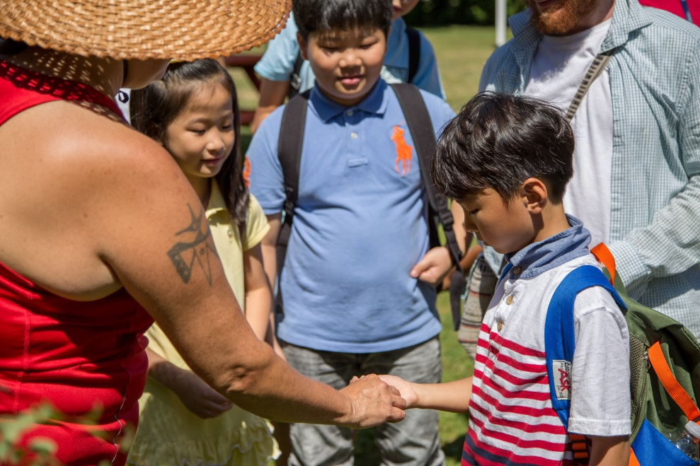

May 9-June 21, 2017

Student volunteers will work with our Indigenous educator to provide fun, interactive learning activities for children on local Coast Salish history and culture at Burnaby Village Museum. Training and guidance for student volunteers will be provided by local Indigenous community members as well as Museum staff.

We are working closely with the Tsleil-Waututh, Squamish, Musqueam and Kwantlen Nations on educational programming here at the Museum. Priority will be given to qualified candidates of Aboriginal ancestry.

If you are interested in these positions, please see [Aboriginal enhancement teacher? Work experience facilitator?] for an application form, specific volunteer dates, and mandatory training dates.

Application deadline: Friday, March 31

For more information about Burnaby Village Museum and the program, contact Sanya Pleshakov at sanya.pleshakov@burnaby.ca or visit www.burnabyvillagemuseum.ca.

